Step 1:

Point your browser to <http://www.constantcontact.com>

Step 2:

Click login near the upper right hand corner as indicated in the screen shot.

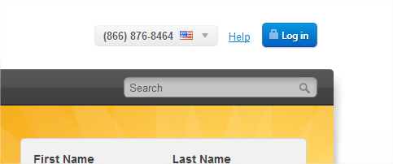

Step 3:

After logging in click the email tab near the top on the left hand side.

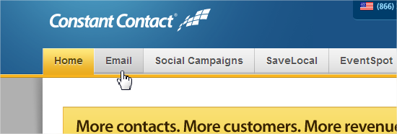

Step 4:

This shows you all old emails that have been sent via constant contact. Locate one that we can copy for the type of email you are attempting to send out. All planning notifications can reuse the PC template that exists in this location already. Once you have found a previous email click the actions drop down on the left hand side of the screen and choose the option to copy.

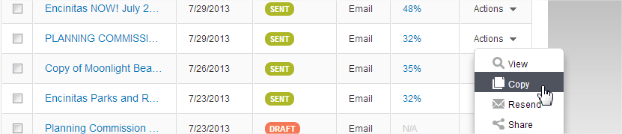

Step 5:

After copying the email click the pencil as indicated in the screen shot below to edit the title of this email.

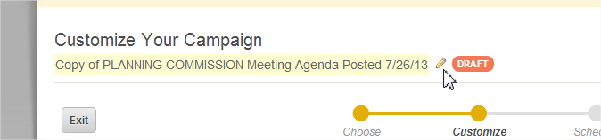

This is for you, not the end user. This is how you will find your old emails should you ever need to look up any statistics on an email.

Step 6:

After naming your email hover the mouse over the body of the email, you will see a floating console action menu that has a pencil. Clicking the pencil will allow you to modify the body of the email. If you need to modify the message click this and begin editing.

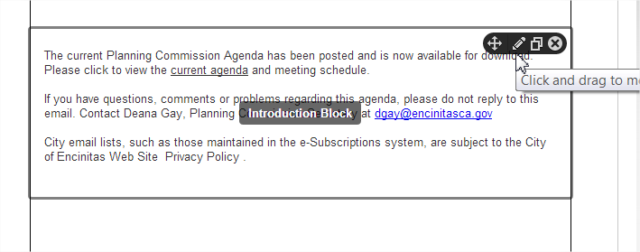

Step 7:

If you edit the message you are presented with a very simply WYSIWIG Editor. At this point you should know the basic functionality of these types of editors and should be able to manage with this.

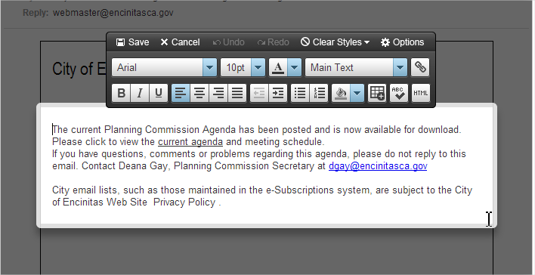

Once done editing click the save option.

Step 8:

After making any modifications to the email that are needed click the save option on the right hand side of the screen. Once saved use the Preview option and review your email.

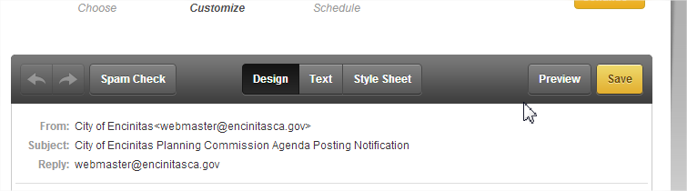

Step 9:

This interface allows you to send a test email to yourself. Replace the webmaster email with your email and click to send a test send. Wait for the email to arrive in your inbox and review the email for formatting, spelling and grammar accuracy.

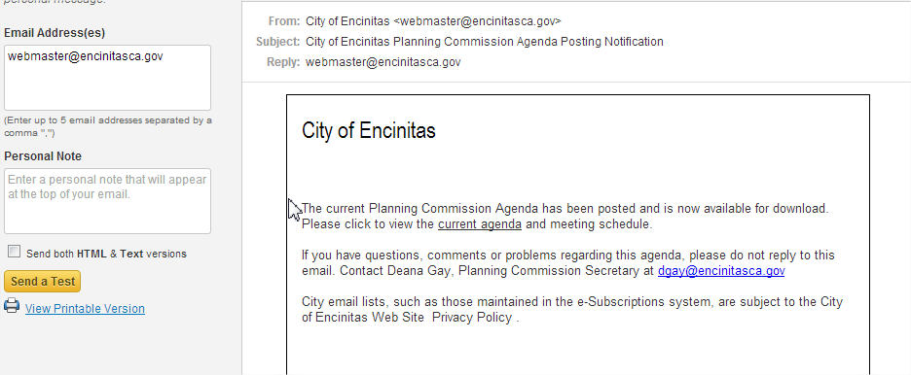

Step 10:

After reviewing the email, close out of the preview section and click the continue option on the right hand side of the screen

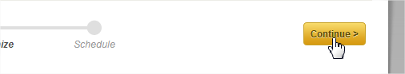

Step 11:

You are now presented with a form that needs to be checked for accuracy and any blank form fields filled in. The subject line can be modified to your liking. The send to list should contain your appropriate Email list. This is the most important detail of the entire process. Only send emails to YOUR lists. The last three fields do not need to be modified. Once the form is complete hit the Schedule button on the right hand side of the screen.

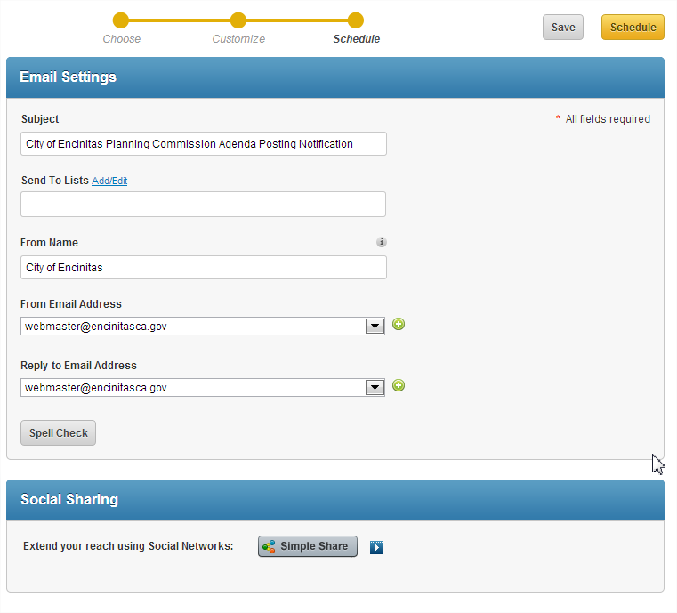

Step 12:

After clicking schedule you are presented with one final form. You have the option to send the email now or send later. If you chose send now the email will schedule to send within 15 min. Sending later will allow you to schedule an email to be sent at some time in the future. Uncheck the box for sending early results reports, then click ok. You should now be notified you are complete with a message letting you know when your email will be sent.

